Faculty of Engineering, Applied Sciences, and Technology
Lab Project

Course Code: BCS202 | Course Name: Introduction to Computing Science II
Date of Submission: 22nd November 2025 | Instructor(s): Dr. Mehak Khurana & Dr. Hamza

Course Learning Outcomes
CLO-3 | Evaluate Java applications by examining exception handling and adherence to object-oriented principles.
CLO-4 | Apply structured solutions to computational challenges by employing advanced programming constructs and design principles

DETAILS OF GROUP MEMBER
NAME OF STUDENT | STUDENT ID
Alisha Taibek | 20240005088
Ayham Nassif | 20240005740
Mohammed Azazi | 20240005212

Table of Contents
Cover Page 1
Introduction 3
Problem Statement and Solution 3
UML representation of classes 4
Main Classes 5
Implementing Exception Handling 9
GUI: 10
Testing: 11

Introduction
This project is a user-friendly application that manages storing and updating a list of products and their associated attributes. It is written in Java, integrating Object-Oriented Programming (OOP) concepts. Beyond the required menu-style functionality (that can be used in the terminal), a graphical user interface (GUI) was created as well to improve comfort and usability for the user.

Problem Statement and Solution
Retail stores and small business often struggle with managing their inventory because of the manual methods, which leads to inaccurate records, not updated prices, and difficulty tracking perishable items with their expiration dates. To address this, this project develops a console-based java application “Inventory Management System.” The system helps managers store and monitor their products efficiently through these operations:
- Adding a new product to inventory
- Viewing all products
- Updating product details
- Deleting a discontinued product
- Searching for product using their ID

UML representation of classes
- Product and PerishibleProduct Classes:
Represents a general product in the inventory.
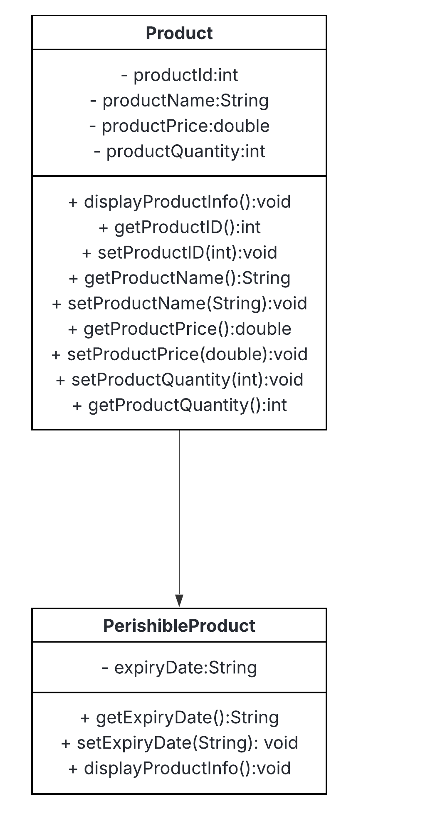
Each product has a unique ID, a name, a selling price, and the quantity available in the inventory. It has a parameterized and a default constructor, that creates a product.
It also extends the PerishibleProduct class, which inherits all attributes and methods of the Product class. It has its own additional attribute, expiryDate, which contains the expiration date of the product.
The method from the Product class, displayProductInfo(), gets overridden if it is expired.
- InventoryManager Class:
Manages all inventory operations with add, view, update, delete or search a product.
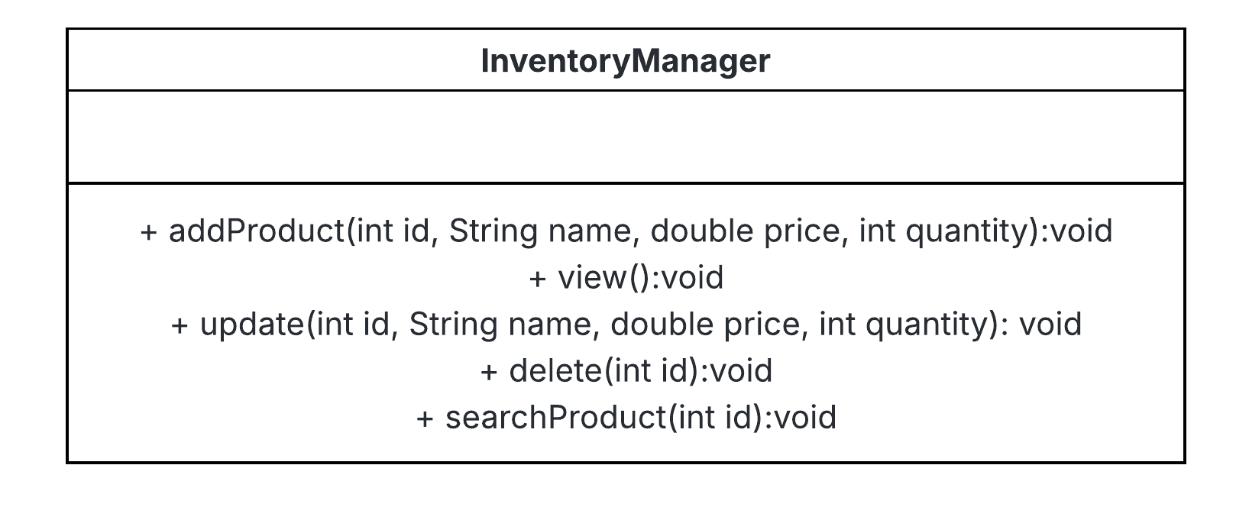
Has no attributes but has a fixed-size array for storing the products, and the methods for operating the product.
- Main Class
Handles the user interactions and the menu layout.
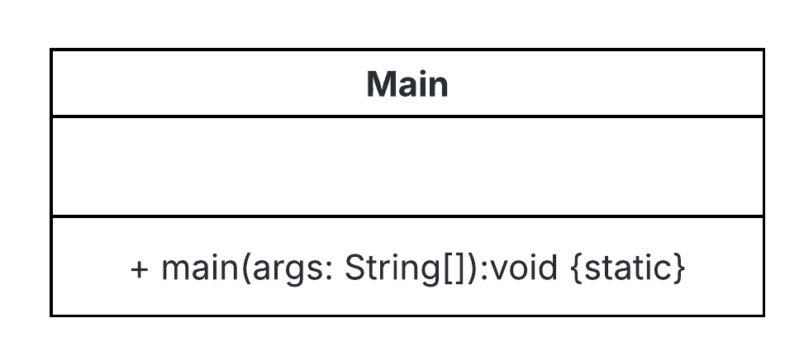
- Custom Exception Classes
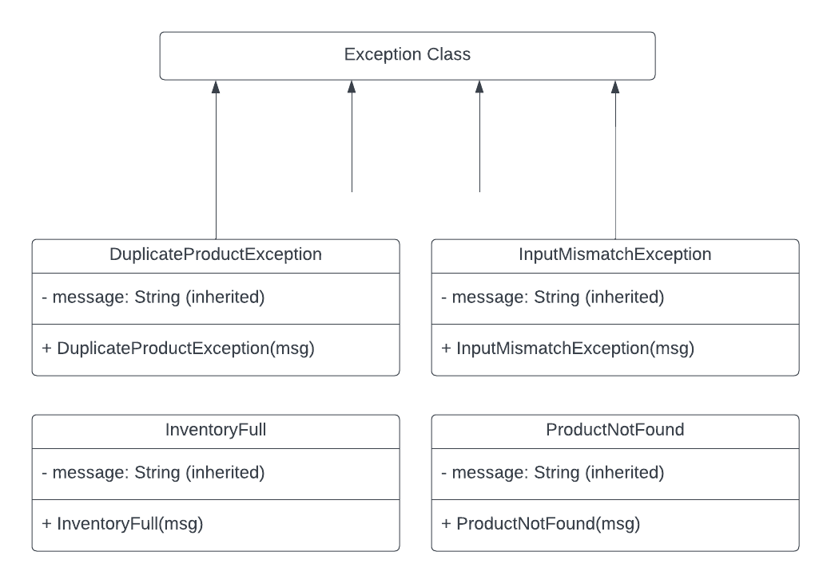

Main Classes
- Inventory Manager:
InventoryManager.java file that contains the operations that can be done by the user to the list of products:
We have a products array that contains 50 (maximum number) cells with default values, and will store the products when created.
- An addProduct method that checks whether the product the user is trying to create is existent; if existent, it throws a custom exception DuplicateProductException that alerts the user, and if non-existent, it will add it to the list.
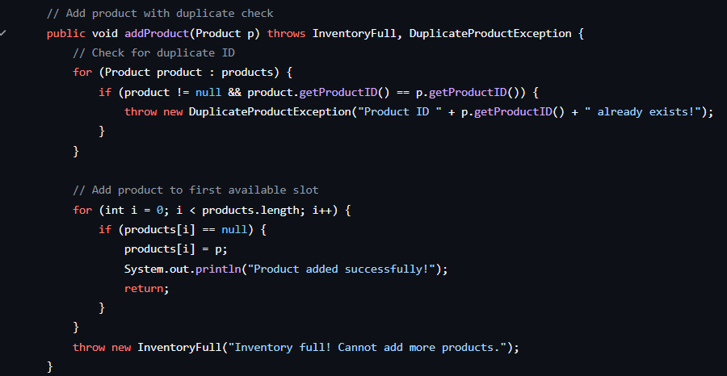
- A view method that displays all of the available products in the list using the already existent displayProductInfo method within the Product.java file.
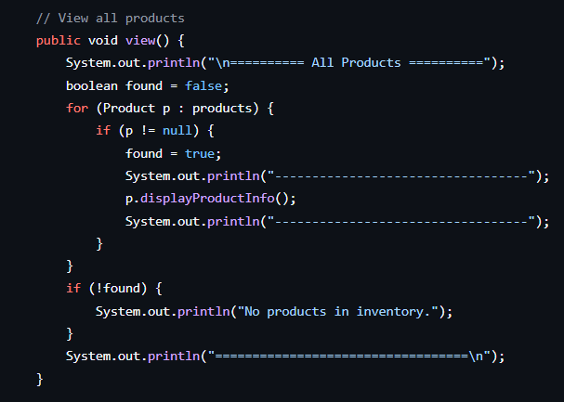

- An updateProduct method that uses setter and getters from the Product.java file to retrieve the private variables of a product. It then updates the product details using the values given by the user.
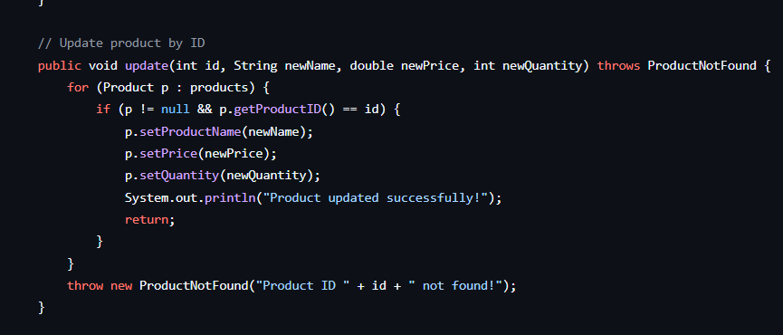
- A delete method that checks whether the product ID entered by the user is existent, and if so, deletes it, otherwise throws a ProductNotFound custom exception which alerts the user that it was not found
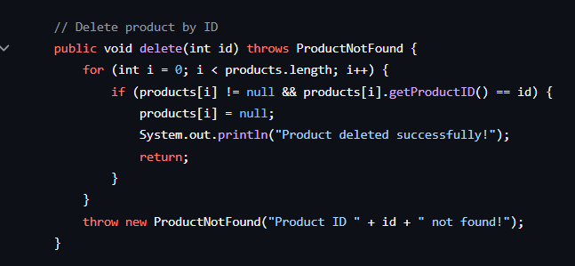
- searchProduct method that searches the product using product ID that was inputted by the user, and if the product doesn’t exist, throws the ProductNotFound custom exception.
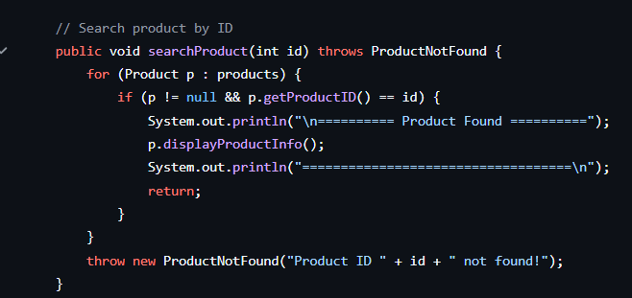
- Perishable Product
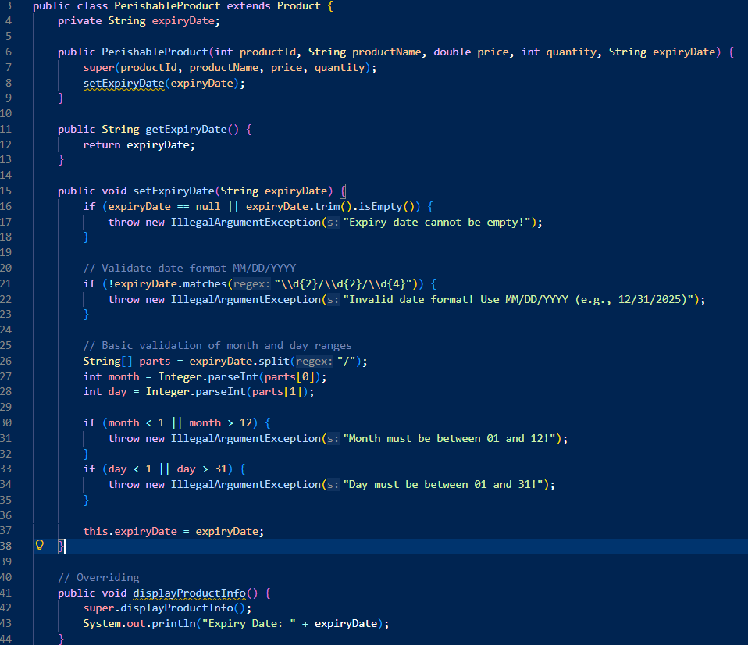
Extension of the Product class and represents items that have an expiration date. It has an additional attribute (aside from the Product ones): expireDate. The class validates user input to ensure that the expiry date is not empty and follows a certain format (MM/DD/YYYY).
This class also overrides the displayProductInfo() method from its parent class because the displayProducInfo() does not include the expiry date. PerishableProduct is an excellent example of inheritance and method overriding.

Implementing Exception Handling
- InputMismatchException that is thrown when the user enters a value of the incorrect type. It is caught in the input-handling sections. It has a constructor that calls super(message) to pass an error message.
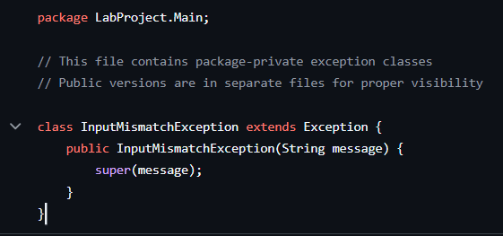
- InventoryFull, a custom exception that signals that the inventory of 50 products is full.
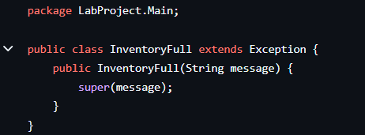
- DuplicateProductException, a custom exception that signals that the product with the given ID already exists in the array.
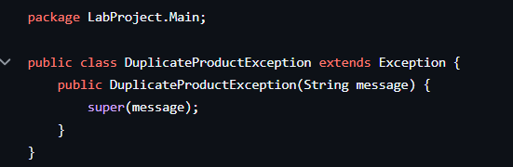
- ProductNotFound exception that signals when the given ID does not match the ID of any product that’s in the inventory.
The MainApp.java has a try-catch for invalid input types:
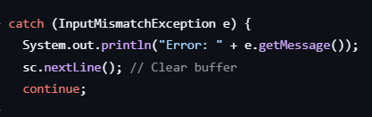
The operations throw exceptions when the errors happen, and they are caught in the main program since the method is called within the try-catch block. Example:
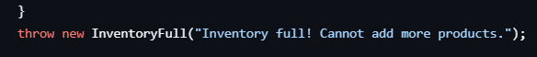

GUI:
GUI Implementation: graphical user interface (GUI) for this project was developed using Java Swing, allowing for a user-friendly and interactive experience. The GUI serves as the main point of interaction for users, enabling them to manage inventory through various panels and actions. The implementation focuses on modularity, ease of use, and maintaining a clear separation between different functionalities.
Structure: The GUI is structured using multiple panels organized within a main application window (`MainFrame`). Each major functionality of the inventory system (adding, viewing, updating, deleting, or searching products) is encapsulated in its own panel class:
- ‘MainFrame’ – main application window
- `MenuPanel` – The main navigation panel, providing access to other features.

Testing:
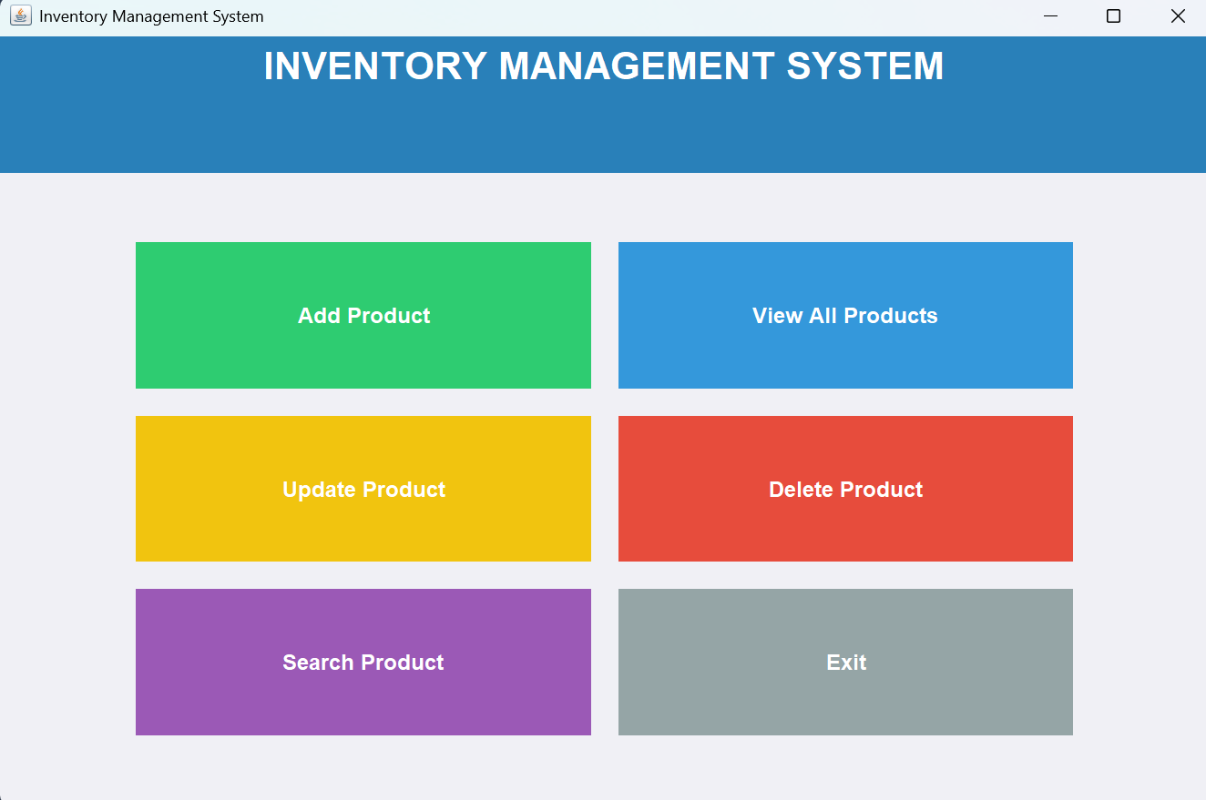
- `AddProductPanel` – Allows users to add new products to the inventory.
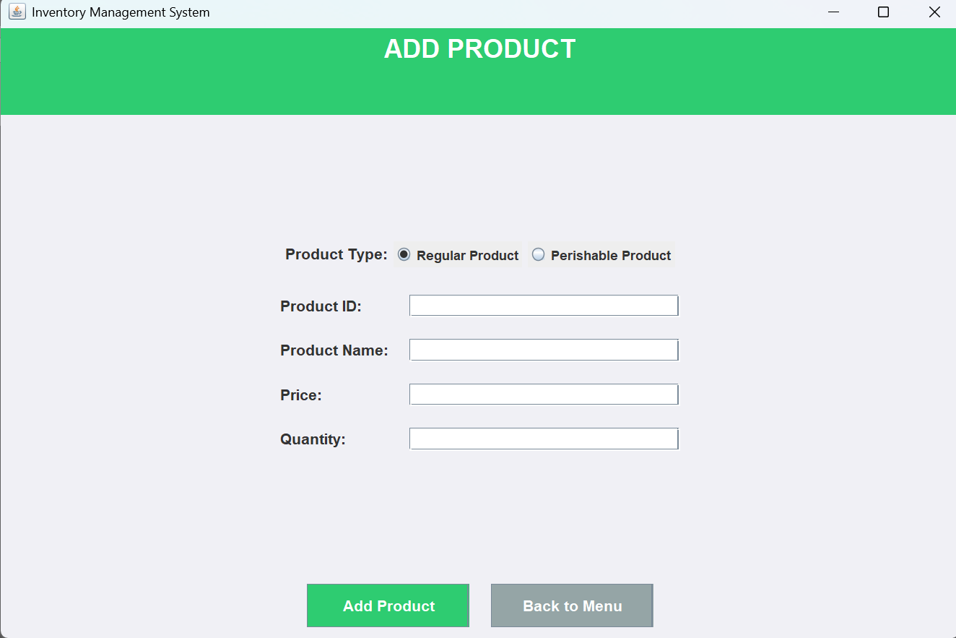
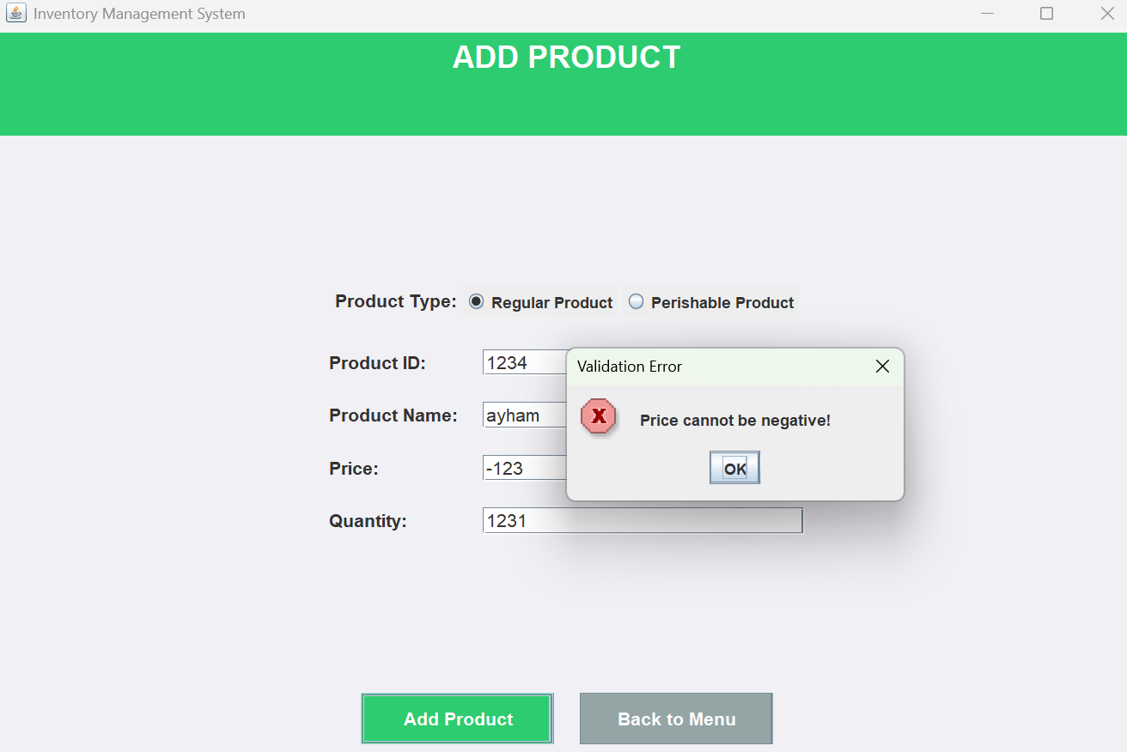
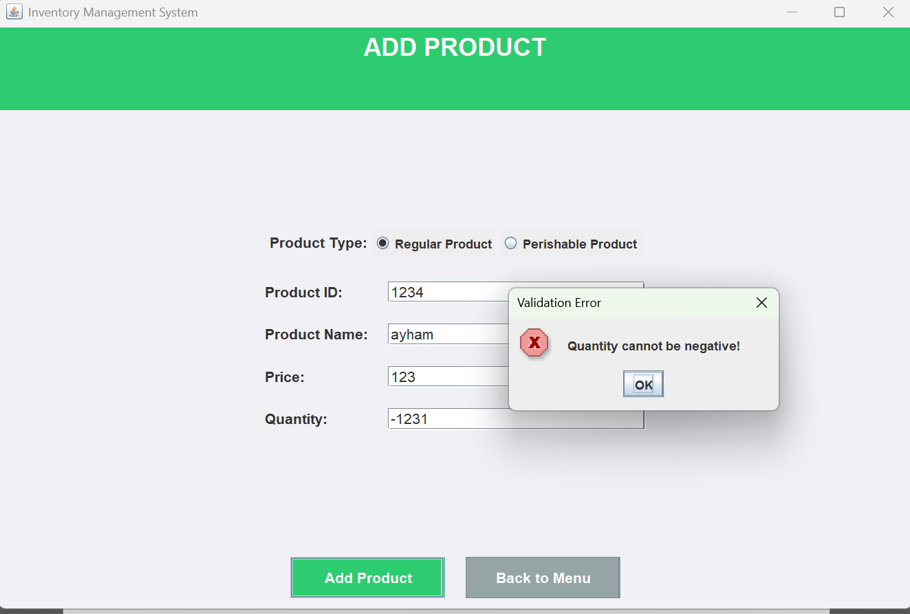
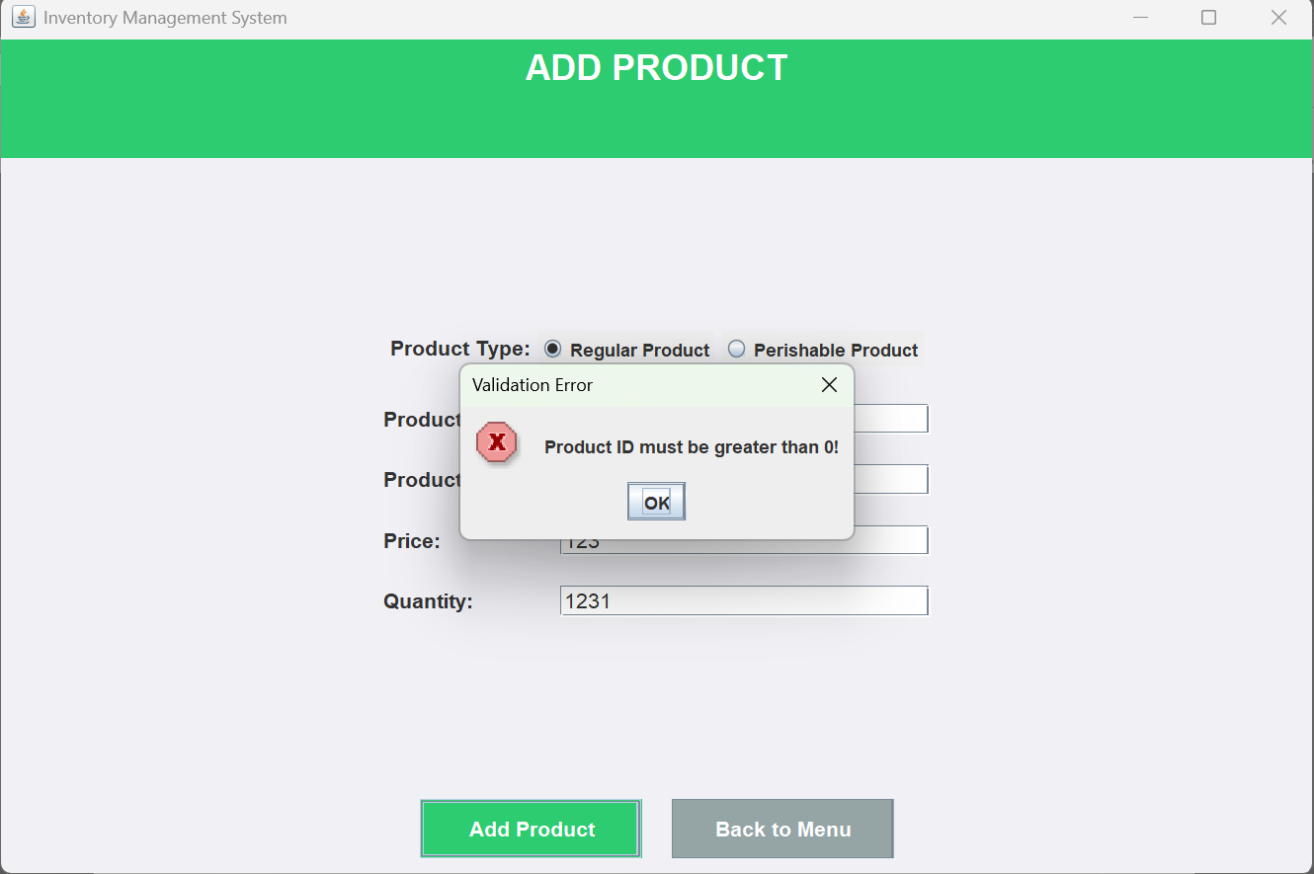
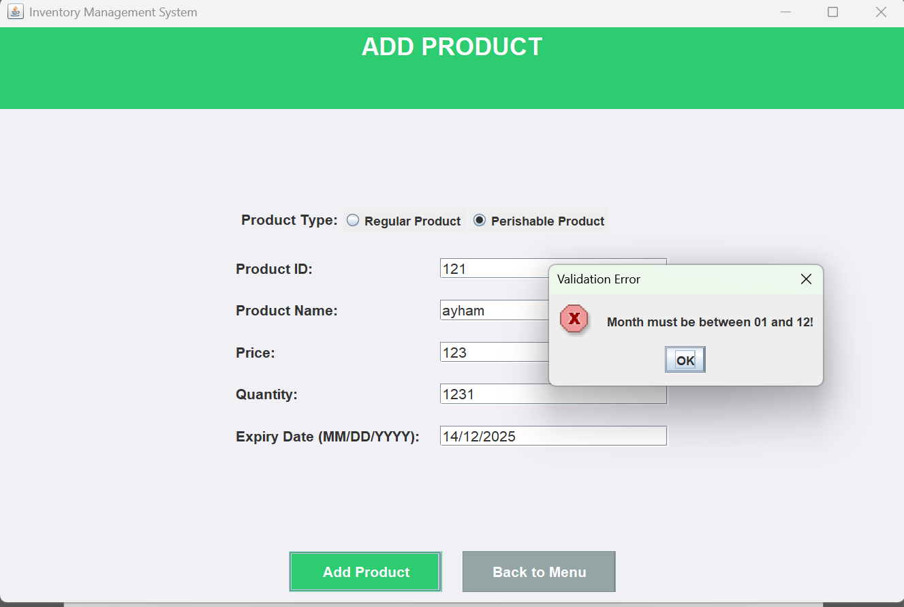
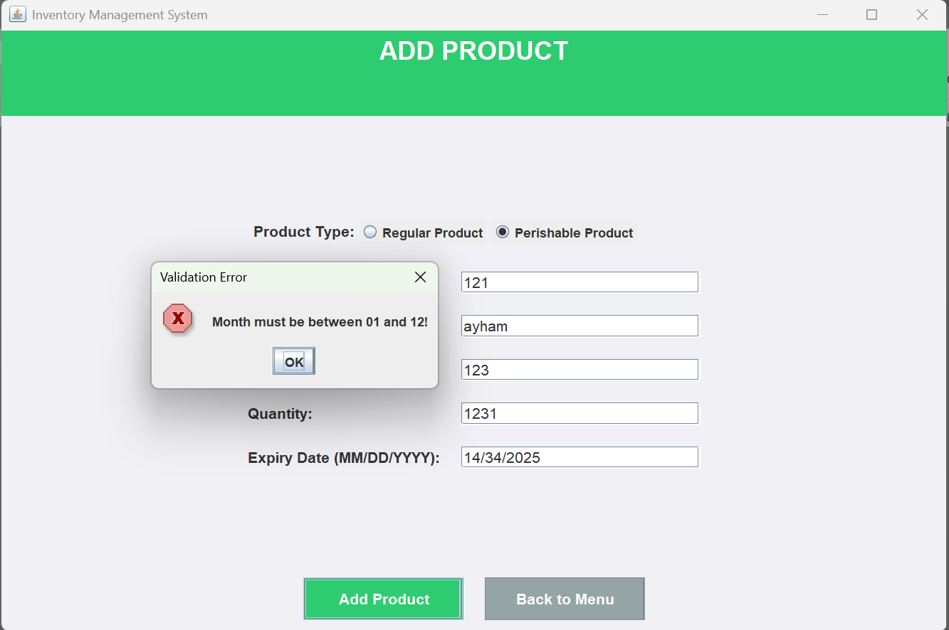
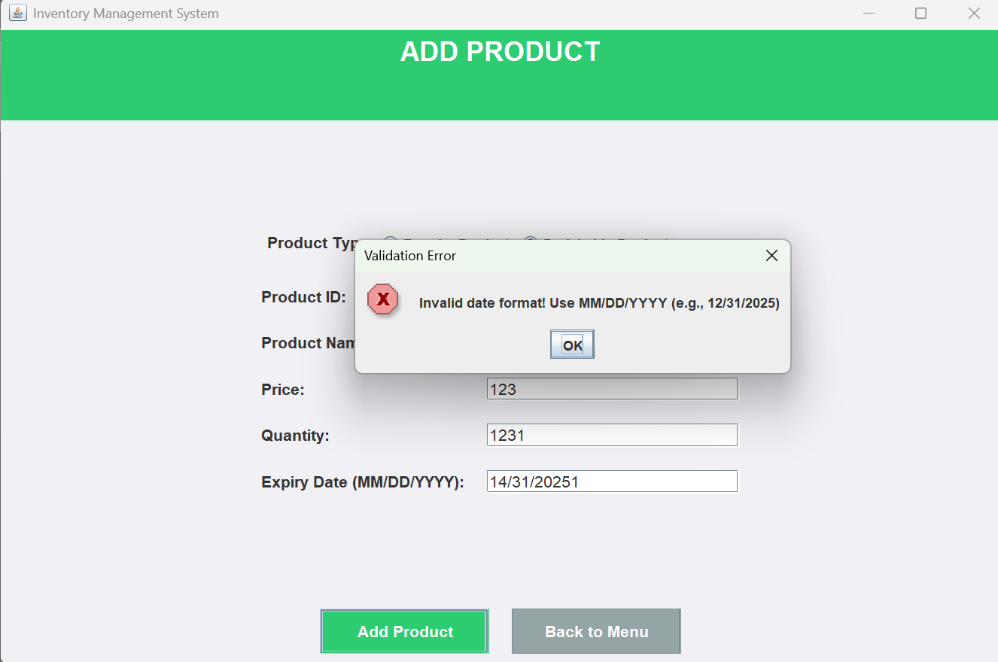

- `ViewProductsPanel` – Displays a list of all products.
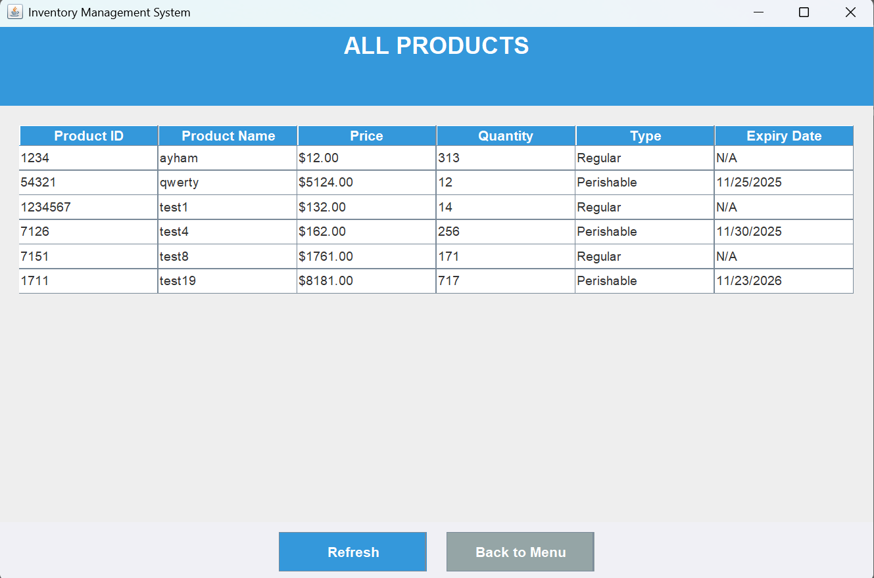
- `UpdateProductPanel` – Enables modification of existing product information.
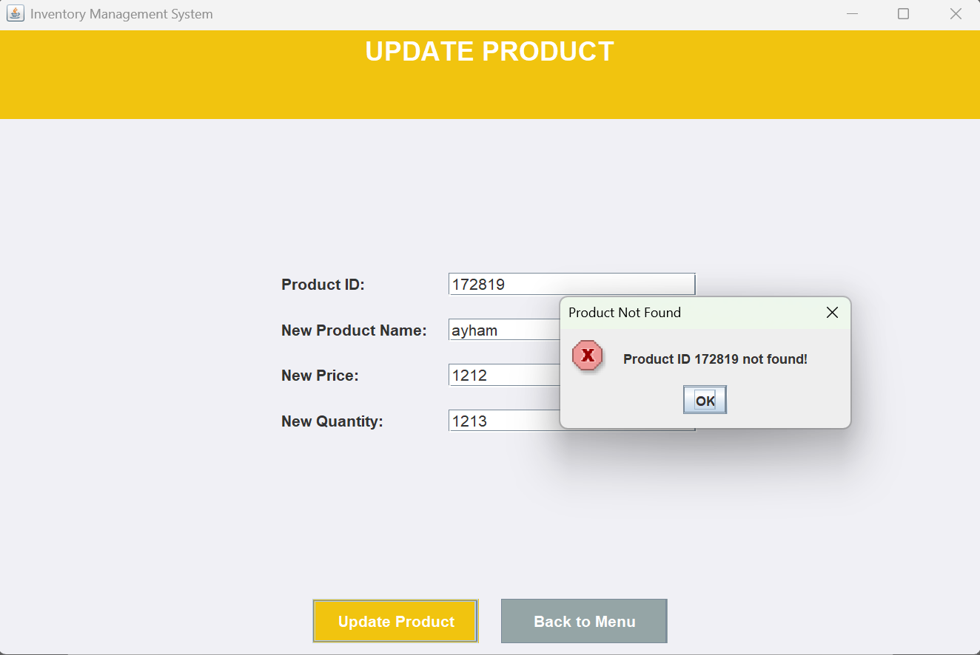
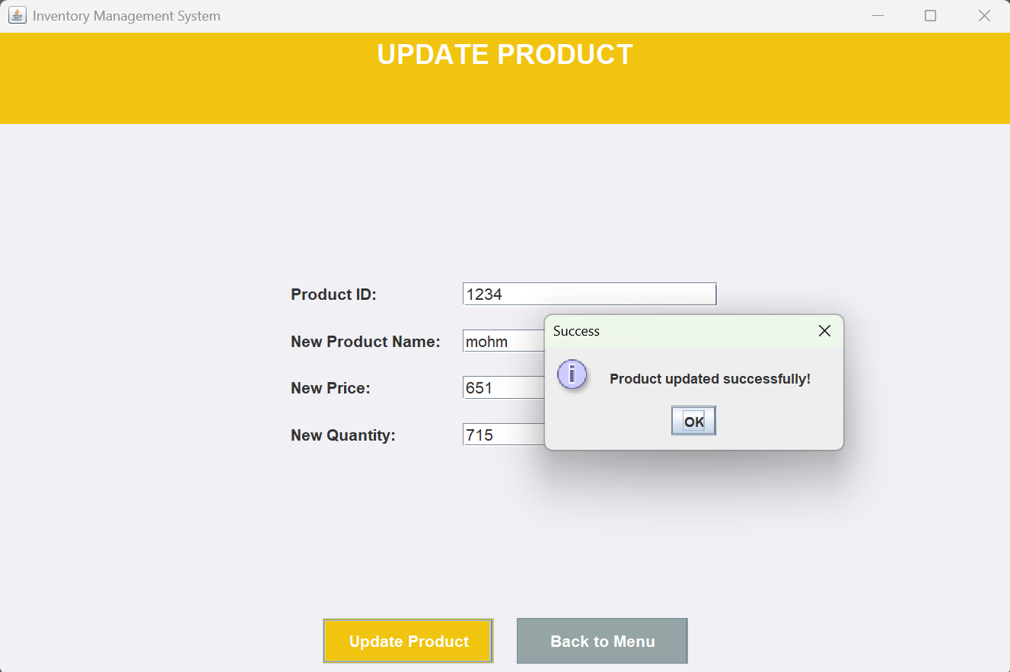
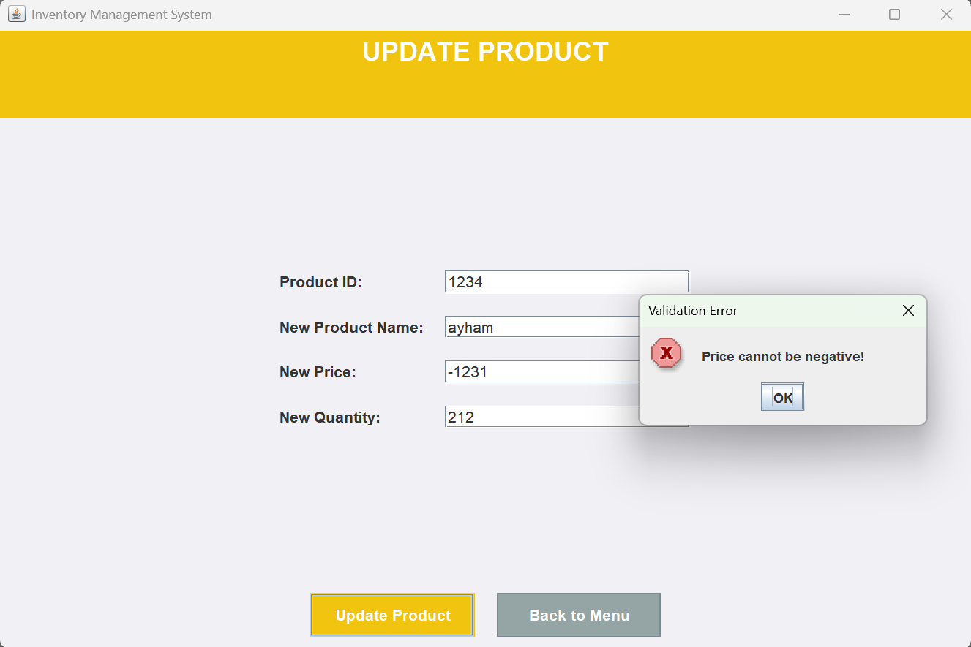
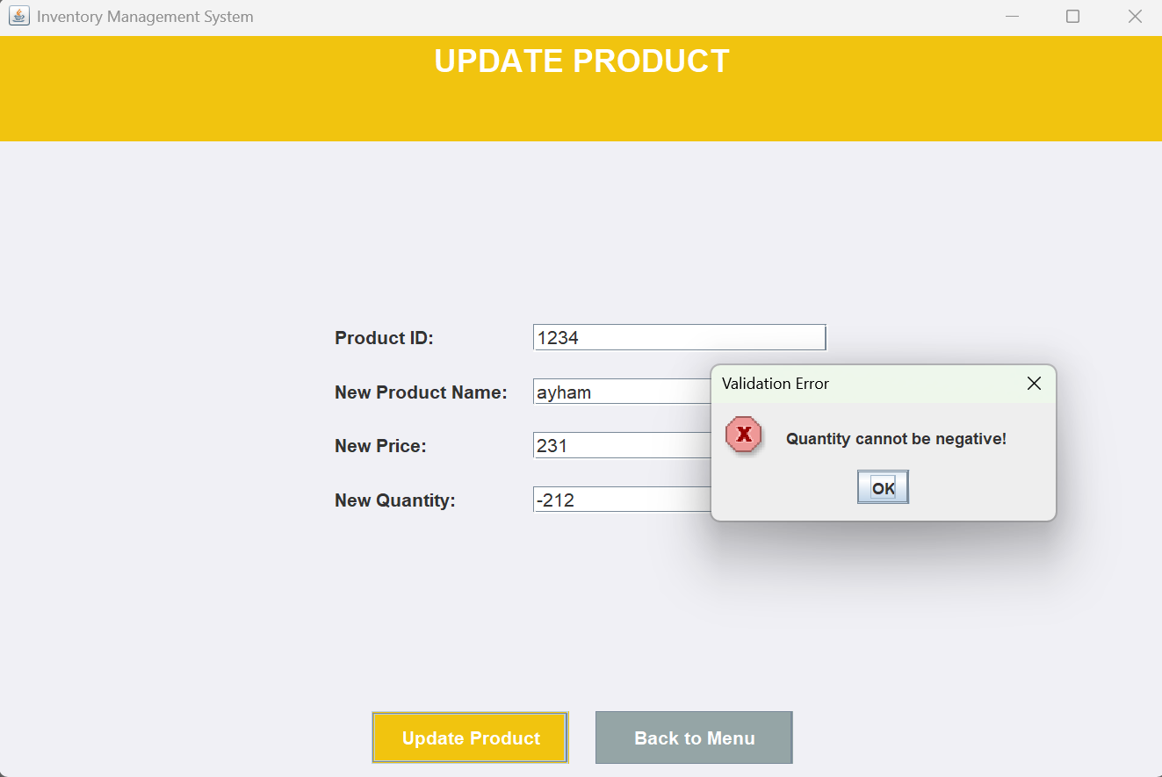
- `DeleteProductPanel` – Handles removal of products from inventory.
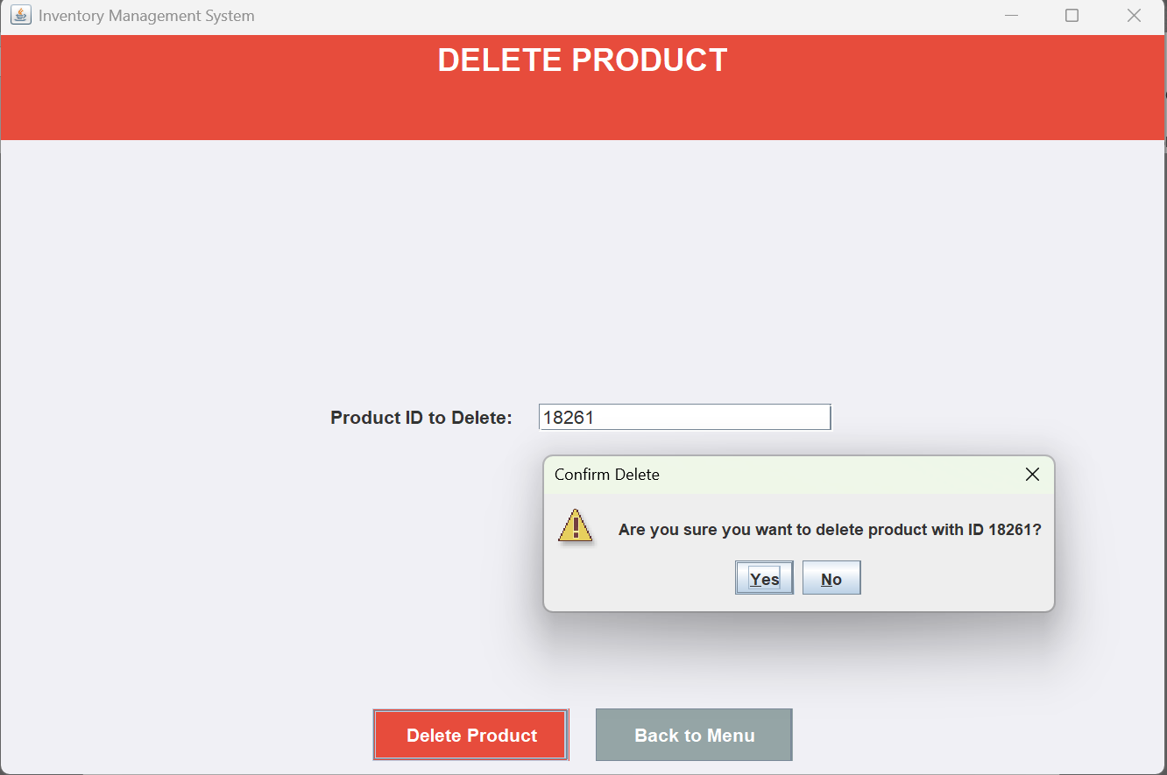
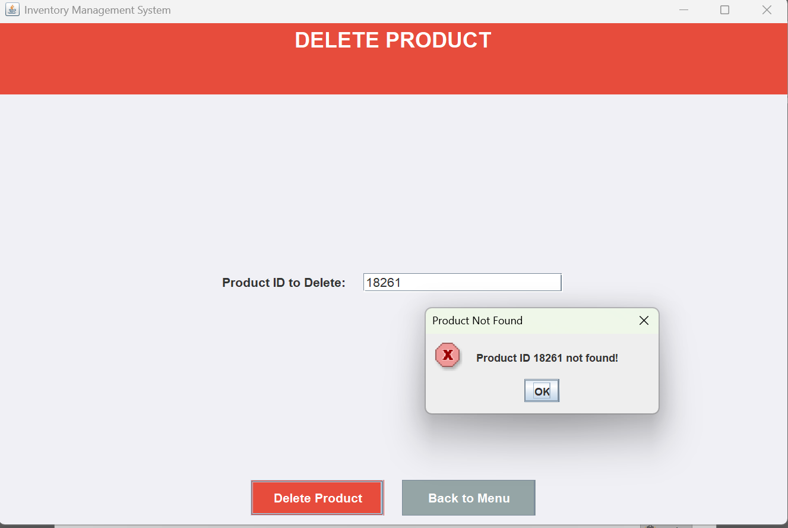
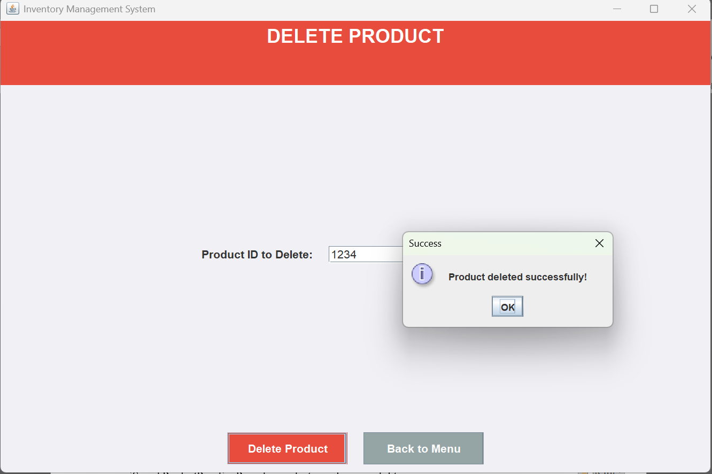
- `SearchProductPanel` – Provides product searching capabilities.
